NAO Watchdog
Lloyd Gibson, Mario Zavala

Draft 5
2015-12-12

CNT 4104 Software Project in Computer Networks
Instructor: Dr. Janusz Zalewski
Department of Software Engineering
Florida Gulf Coast University
Ft. Myers, FL 33965

1. Introduction
Security is a big issue in today’s world. As new technologies emerge, so does the need to be better protected against new threats that come with these technologies. The objective of this project is to use a NAO robot [1] as a “watchdog”, taking advantage of its various capabilities. This project is a continuation of the project “NAO Watchdog” created by the student Jessel Serrano in the Fall of 2013 [2]. The project of Jessel Serrano focuses on the NAO robot as a security device. The current project takes what Jessel did and expands on the functionality that the NAO robot can bring as a security device using its various hardware and software components. As mentioned before, the NAO robot has various hardware components (cameras, microphone, etc.) that can transform this friendly-looking robot into a security device that can locate and keep track of an object. The networking capabilities of the robot are also used, along with its cameras, to stream a live feed of the area being “watched” by the robot.

2. Software Requirements Specification
The previous project was able to get the NAO to respond correctly to audio stimulus, i.e., the NAO turned to look in the direction of detected sound. The NAO also streamed live video to the client. There were, however, issues with the sensitivity of the microphones and the occasionally erratic movements of the robot. An improvement to be made on the previous project is to alleviate this disadvantage by filtering out certain sounds.
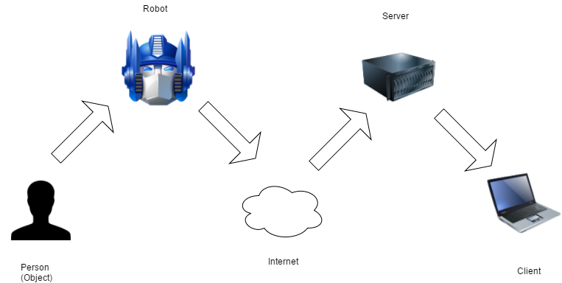
Figure 1: Physical Diagram
The physical components of the project are shown in Figure 1 above. The relationship among these components is also shown. When an object is detected by the sensors of the robot, live feed of the object is sent to the client computer, passing through the Internet and server along the way.
The software consists of two programs: the Tracker, running on the NAO robot, and the Watcher, running on the client computer, as shown in Figure 3. The general behavior of the two programs can be describes as the follows:
- Tracker will be waiting for movement or sound from person or object.
- Tracker will accept client connections from Watcher, running on the client computer.
- Tracker sends live images to Watcher.
- Watcher displays images to the user.
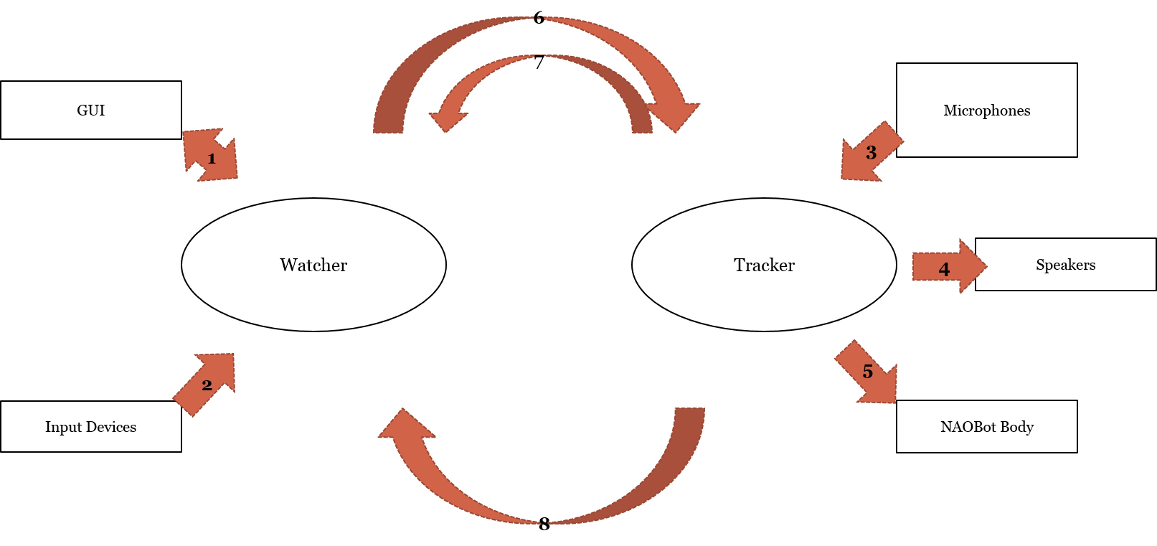
Figure 2: Context Diagram
The Context Diagram is shown in Figure 2. The two main pieces of software each have input and output messages to the outside world. The Watcher (1) displays image from the NAOBot and status messages in the GUI and (2) receives user input through the mouse. The Tracker (3) receives audio data through its microphones, (4) emits audio notifications through the speakers and (5) controls the NAOBot’s body in response to events and commands. The Local and Trackers are connected through two streams. Through the first stream, the Watcher (6) sends commands and queries to the Tracker which (7) responds which confirmations and image data. The second stream (8) allows the Tracker to send status messages to the Watcher.
The requirements of the project are the following:
- The Tracker shall utilize its microphones and other sensors to determine if an object is present in its view.
- The Tracker shall turn its head to keep objects and/or persons within its view.
- The Tracker shall stream the image data across the Internet where a remote user can access the feed.
- The Watcher shall query the Tracker for image data.
- The Watcher shall accept head movement commands from the user
- The Tracker shall move the robot’s head in response the movement commands from the Watcher

3. Design Description

3.1. Software Architecture
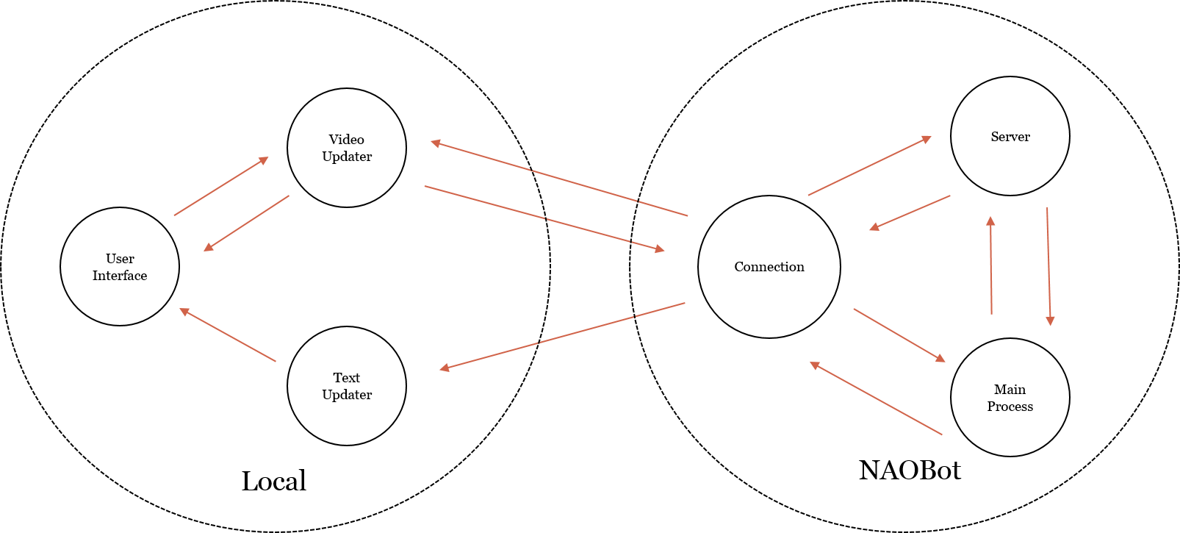
Figure 3: Software Architecture
The architecture of the software developed is presented in Figure 3. As shown in the figure, there are two main programs to be developed: the Tracker and the Watcher. The Tracker runs on the NAO robot and the Watcher runs on the client computer.
The Watcher is comprised of three main components, the User Interface, the Video Updater and the Text Updater. The User Interface component displays the image output and handles user input. Depending on the input from the user, the User Interface component may also send command messages to the NAOBot through the Video Updater. The Video Updater handles the first stream to the NAOBot described in the previous section, i.e. it sends commands and queries to the NAOBot and receives image data from it. It also refreshes the image data in the User Interface. The Text Updater handles the second stream, receiving status updates from the Tracker and relaying them to the User Interface.
The Tracker is also made up of three components, the Connection, Server and Main Process components. The Connection component handles the connection to the Watcher. The Server component listens for new connections from instances of the Watcher. This is for scalability concerns as the current system only calls for a single instance of the Watcher. The Main Process is in charge of handling sound events and controlling the NAOBot’s body.

3.2. Detailed Design

3.2.1 Classes
The main classes to be developed are displayed in the Class Diagrams of Figures 4 and 5.
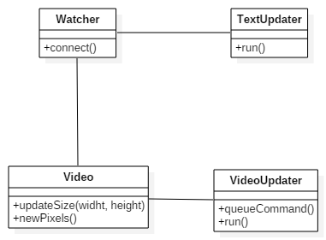
Figure 4: Classes of the Watcher
In the Watcher software, the User Interface Component will be realized by two main classes, Watcher and Video. The Watcher class will be both the top container for all the UI components and the driver of the Watcher. It will also hold the mechanisms for establishing the initial connection to the Tracker. The Video class is a placeholder for the images from the NAOBot. It will hold the mechanisms for updating the image when new data is retrieved. That data is retrieved by the VideoUpdater class which, obviously, is the realization of the Video Updater component. Similarly, the TextUpdater class realizes the Text Updater component. Both updaters will run on their own threads, hence the run() methods. The VideoUpdater, being in charge of sending commands to the NAOBot, will also have a function for receiving commands from the Watcher, i.e. queueCommand().
In the Tracker software, each component will be realized by on class. The Main Process will be the SoundTrackerModule class, the Server component will be the ConnectionListener class and the Connection component will be the ConnectionThread class. The SoundTrackerModule will mainly be in charge of listening to sound events. The two type of events, SoundDetected and SoundLocated, will be handled by the onSoundDetected() and onSoundLocated() functions respectively. The class also will have the functionality for setting up ( and destroying) the server and subscribing (and unsubscribing) to the sound events.
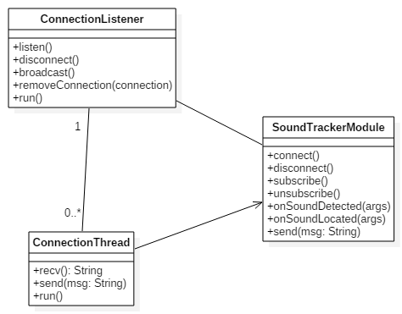
Figure 5: Classes of the Tracker
The send() function is there to allow sending status messages to all connected instances of the Watcher. The ConnectionListener is the nexus for all instances of the ConnectionThread class. Status messages will be distributed to the threads through the broadcast() function. There will be one instance of ConnectionThread per instance of the Watcher connected to the Tracker. As previously stated, it will handle both connection streams to its Watcher instance.

3.2.2 Behaviors
As previously stated, the Watcher class is the driver of the Watcher. When the application begins, the Watcher will attempt to connect to the Tracker, and if successful, start the VideoUpdater. The operations of the fetching of image data by the VideoUpdater are detailed in Figure 6. After the Watcher starts the VideoUpdater, the updater starts a loop that will continue as long as the application is running. At the beginning of the loop, the updater will send the “fetch” command to the Tracker. The Tracker’s ConnectionThread will respond by retrieving an image from the NAOBot’s camera with ALVideoDevice’s function getImageRemote().
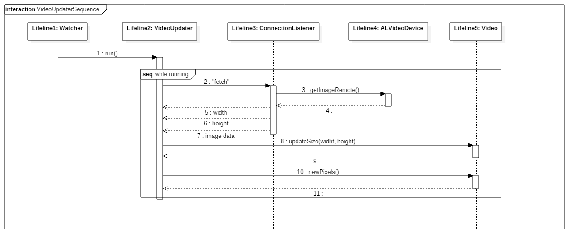
Figure 6: Sequence of the VideoUpdater
After retrieving the image, the ConnectionListener will send the width, height and image data to the Watcher. The VideoUpdater will then send the width and height to the Video class to check if the size of the image has changed, and then send the image data and alert it to the updated image. Then the process will start again.
When the user clicks on one of buttons surrounding the image, the Watcher queues a “move-xxx” command (where xxx is “left”, “right”, “up” or “down”). The VideoUpdater, when it begins another iteration, will check the queue for commands and send any if they exists. The ConnectionThread will then process the command by, in the case of a “move-xxx” command, moving the head in the direction specified.
When the Tracker starts, it will register the SoundTrackerModule as a listener to the SoundDetected event. When a sound is detected near the NAOBot, the onSoundDetected() function is run which will then register SoundTrackerModule as a listener to the SoundLocated event for 8 seconds. During this time, any SoundLocated events will trigger the onSoundLocated() function which will attempt to turn the head of the NAOBot in the direction of the perceived sound. At the end of the 8 seconds, the NAOBot will stop listening for SoundLocated events. This is necessary to prevent erratic movement from the ALAudioSourceLocalization module which plagued the previous project. This way, the NAOBot will react only after the more reliable SoundDetected event is triggered.

4. Implementation and Testing
The implementations of the two pieces of software are quite different. In the previous project, both pieces were written in Java and made use of the Aldebaran API. This project, however, made use of Naoqi only in the NAOBot software. The Watcher was written in Java but was oblivious to the working of the NAOBot. It communicated with the NAOBot not through the methods used by Aldebaran but through a simple socket protocol.

4.1 Watcher

4.1.1 Implementation
As stated above, the Watcher was written in Java. The user interface is very simple. It consists of a text area and the image panel surrounded by four buttons for moving the camera. A screenshot of the interface is shown in Figure 7. The interface is initialized in the Watcher’s constructer with the following code.
JPanel center = new JPanel(new BorderLayout());
add(center, BorderLayout.CENTER);
center.add(video = new Video(width, height), BorderLayout.CENTER);
center.add(new JButton(new AbstractAction("Turn Left") {
public void actionPerformed(ActionEvent e) {
commandQueue.add("move-left");
}
}), BorderLayout.WEST);
center.add(new JButton(new AbstractAction("Turn Up") {
public void actionPerformed(ActionEvent e) {
commandQueue.add("move-up");
}
}), BorderLayout.NORTH);
center.add(new JButton(new AbstractAction("Turn Right") {
public void actionPerformed(ActionEvent e) {
commandQueue.add("move-right");
}
}), BorderLayout.EAST);
center.add(new JButton(new AbstractAction("Turn Down") {
public void actionPerformed(ActionEvent e) {
commandQueue.add("move-down");
}
}), BorderLayout.SOUTH);
JScrollPane scroll = new JScrollPane(text = new JTextArea());
scroll.setPreferredSize(new Dimension(3000, 200));
add(scroll, BorderLayout.SOUTH);
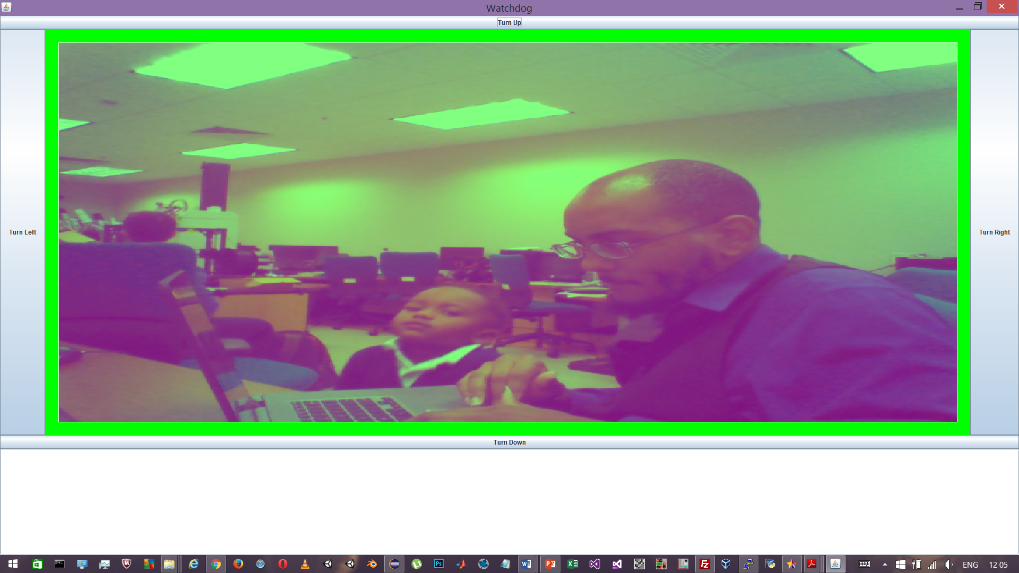
Figure 7: Screenshot of Watcher User Interface
The software connects to the Tracker through sockets. The following snippet establishes the connection.
// The server for connecting to the second NAOBot connection
@SuppressWarnings("unused")
private ServerSocket server;
// The client socket to the NAOBot
private Socket client;
// The server socket to the NAOBot
@SuppressWarnings("unused")
private Socket connection;
// The InputStream for receiving image data
private InputStream dataIn;
// The InputStream for receiving status messages
private InputStream statIn;
// The OutputStream for sending commands
private BufferedWriter comOut;
public void connect() throws UnknownHostException, IOException {
client = new Socket(NAOQI_IP, NAOQI_IN_PORT);
dataIn = new BufferedInputStream(client.getInputStream());
comOut = new BufferedWriter(new OutputStreamWriter(
client.getOutputStream()));
updaterThread = new Thread(updater = new VideoUpdater());
updaterThread.run();
}
The connect() function would have also initialized the server and connection variables but due to security issues the implementation of the text stream was unfinished.
The image panel uses a BufferedImage to hold the data which is recreated every time width or height changes. The array of image data fetched from the Tracker is used to set the rgb data in the BufferedImage.

4.1.2 Testing
The Watcher was tested in two ways. There was another test but the implementation of the test was faulty. The first test was mocking the NAOBot and the second was integration testing with the NAOBot. Mocking the NAOBot was done in two ways, the second of which was the unperformed test. The first test circumvented using sockets at all and involved a mock class producing image data and the VideoUpdater class retrieving it through its functions. The code for that version of Watcher can be seen in Appendix 7.3. The result of that test is shown below in Figure 8.
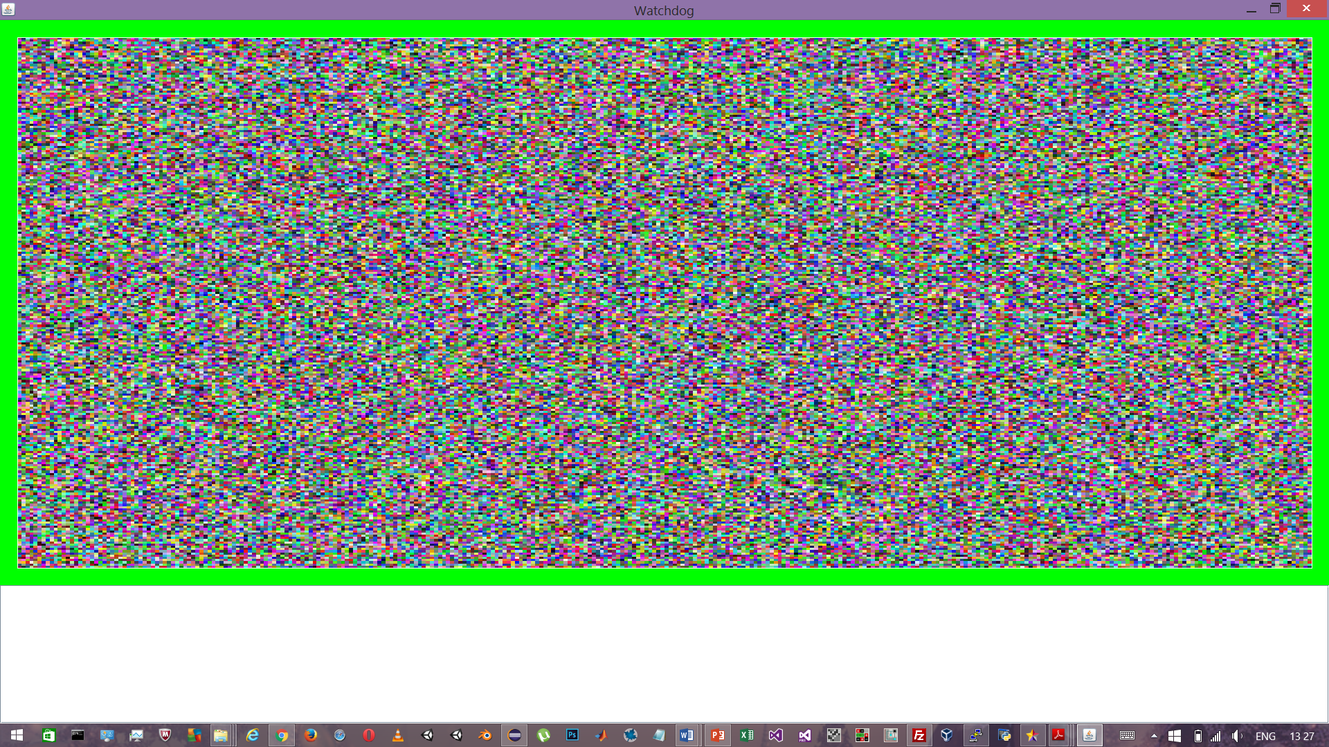
Figure 8: Screenshot of Watcher mock test
The second mock involved a similar class with the difference that it broadcast the image data through a socket. The test was not performed, however, because the Watcher and MockNao could not establish a connection. The code for the MockNao is listed in Appendix 7.4. The final integration test involved running the final code and checking for the camera images. Figure 7 shows the program running. The head movement buttons were also tested, i.e. the buttons were tested to see if the NAOBot would correctly turn its head.

4.2 Tracker

4.2.1 Implementation
The NAOBot software made use of a number of Naoqi classes as shown in Figure 9. The ALTextToSpeech module is used to give audio status messages (this will be disabled if deployed). The ALVideoDevice module is used to fetch images from the camera. The ALMotion module controls the movement of the NAOBot’s body. The ALAudioSourceLocalization. The ALMemory module is key to retrieving event data and registering event listeners.
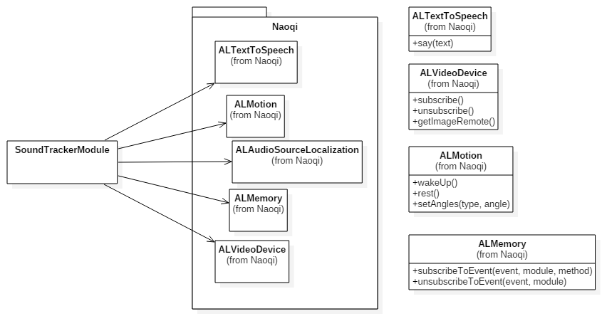
Figure 9: Classes imported from Naoqi
The implementation of the ConnectionThread’s run() function is as follows.
def run(self):
com = self.recv()
while com != "quit" :
print("message received: " + com)
if com == "accepting" :
adr = (self.adr[0], OUT_PORT)
print("connecting to " + str(adr))
self.client.connect(adr)
self.client_connected = True
elif com == "fetch" :
ret = self.tracker.video.getImageRemote(self.tracker.nameID)
self.con.send((str(ret[0])).encode('utf-8'))
self.con.send((str(ret[1])).encode('utf-8'))
l = len(ret[6])
i = 0
while i < l :
u = l
if u - i > 512 :
u = i + 512
self.con.send(ret[6][i:u])
i = u
elif com == "move-left" :
st = self.tracker.robot.getStiffnesses("Head")[0]
self.tracker.robot.setStiffnesses("Head",1)
self.tracker.robot.changeAngles("HeadYaw", .1, .1)
self.tracker.robot.setStiffnesses("Head",st)
elif com == "move-up" :
st = self.tracker.robot.getStiffnesses("Head")[0]
self.tracker.robot.setStiffnesses("Head",1)
self.tracker.robot.changeAngles("HeadPitch", -.1, .1)
self.tracker.robot.setStiffnesses("Head",st)
elif com == "move-right" :
st = self.tracker.robot.getStiffnesses("Head")[0]
self.tracker.robot.setStiffnesses("Head",1)
self.tracker.robot.changeAngles("HeadYaw", -.1, .1)
self.tracker.robot.setStiffnesses("Head",st)
elif com == "move-down" :
st = self.tracker.robot.getStiffnesses("Head")[0]
self.tracker.robot.setStiffnesses("Head",1)
self.tracker.robot.changeAngles("HeadPitch", .1, .1)
self.tracker.robot.setStiffnesses("Head",st)
com = self.recv()
com.send("disconnecting")
con.shutdown(socket.SHUT_RDWR)
con.close()
self.tracker.listener.remcon(self)
The function loops until it receives a quit command. The implemented commands are “fetch”, “move-xxx” and “quit”. The “fetch” prompts ConnectionThread to retrieve an image using ALVideoDevice’s getImageRemote() function. It then sends the width and height, each using three digits, and then the image data in chunks of 512 bytes.

4.2.2 Testing
Two tests were performed. The first involved running the code and making sounds to see if the robot would turn to face them. The second test was the integration test where we checked if the camera images were being properly sent.

5. Conclusion
The project was nearly completed, but like any other projects, was not without problems and setbacks. The major setback this project suffered from was the departure of one the team members working on the project. With more work and less time to do it, the project was completed and the requirements were met nonetheless. Another problem was that the first plan was to write both programs in Java, but there were problems downloading the SDK for the NAO and making it work. Furthermore, the accuracy of the sound localization, and there for the head tracking, is inadequate for a deployable project.
The previous project was successful in using the NAOBot’s sensors to locate sounds and stream images to a client application. The project’s implementation was, however, plagued by accuracy issues, i.e. the NAOBot was prone to frequent erratic head movements in response to incorrectly perceived sounds. This project successfully implemented all that the previous project accomplished and arguably corrected the accuracy issue. One component of the design was left unfinished, however, specifically the status text stream. The Nao Watchdog can be deployed to monitor its environment for sound and send images to a remote application. The robot’s head can also be controlled from remote computers as well to counteract any inaccuracies in the sound localization functions.
The previous report stated that the image transfer completed smoothly with low resolution, i.e. 320x240, and this project’s results gave the same result. The erratic head movement was lessened by the SoundDetected event method, however, for a sound to be located, it must be preceded by another detectable sound. That is to say, if something makes a single sound, the application will detect it but not locate it. If an object continually makes a sound, or at least makes two sounds, the application will be able to locate the source. This is subjectively more efficient than the previous projects results.
Further extensions to the project could include the status stream’s completion. Or, as the previous report mentioned, face or motion detection can be used for better tracking.

6. References
[1] Aldebaran, NAO Documentation, Aldebaran, November 18, 2015, URL: <http://doc.aldebaran.com/2-1/home_nao.html?>
[2] Serrano, Jessel, NAO Watchdog, Florida Gulf Coast University, Fort Myers, Fl, December 6, 2013, URL: <http://itech.fgcu.edu/faculty/zalewski/CEN4935/Projects/NAOwatchdog.pdf>

7. Appendix

7.1 rtserver.py
from naoqi import ALProxy, ALModule, ALBroker
import time
import threading
import socket
import vision_definitions

SoundTracker = None
NAO_IP = '10.100.205.180'
IN_PORT = 3000
OUT_PORT = 3001

class ConnectionListener(threading.Thread):
def __init__(self, tracker):
threading.Thread.__init__(self)
self.tracker = tracker
self.server = tracker.server
self.listening = False
self.connections = []

def listen(self):
self.server.setsockopt(socket.SOL_SOCKET, socket.SO_REUSEADDR, 1)
self.server.bind((NAO_IP, IN_PORT))
self.server.listen(5)

def run(self):
self.listen()
self.listening = True
while self.listening :
con, adr = self.server.accept()
conthr = ConnectionThread(self.tracker, con, adr)
self.connections.append(conthr)
conthr.start()

def remcon(self, con):
self.connections.remove(con)

def broadcast(self, msg):
for con in self.connections :
con.send(msg)

def disconnect(self):
self.running = False;
for con in self.connections :
con.running = False

class ConnectionThread(threading.Thread):
def __init__(self, tracker, con, adr):
threading.Thread.__init__(self)
self.tracker = tracker
self.con = con
self.adr = adr
print(str(adr))
self.client = socket.socket()
self.client_connected = False

def recv(self):
num = int(self.con.recv(3))
com = self.con.recv(num)
while len(com) < num :
com = com + self.con.recv(num - len(com))
return com

def run(self):
com = self.recv()
while com != "quit" :
print("message received: " + com)
# self.con.send(("message received: " + com).encode('utf-8'))
if com == "accepting" :
adr = (self.adr[0], OUT_PORT)
print("connecting to " + str(adr))
self.client.connect(adr)
self.client_connected = True
elif com == "fetch" :
ret = self.tracker.video.getImageRemote(self.tracker.nameID)
self.con.send((str(ret[0])).encode('utf-8'))
self.con.send((str(ret[1])).encode('utf-8'))
l = len(ret[6])
i = 0
while i < l :
u = l
if u - i > 512 :
u = i + 512
self.con.send(ret[6][i:u])
i = u
elif com == "move-left" :
st = self.tracker.robot.getStiffnesses("Head")[0]
self.tracker.robot.setStiffnesses("Head",1)
self.tracker.robot.changeAngles("HeadYaw", .1, .1)
self.tracker.robot.setStiffnesses("Head",st)
elif com == "move-up" :
st = self.tracker.robot.getStiffnesses("Head")[0]
self.tracker.robot.setStiffnesses("Head",1)
self.tracker.robot.changeAngles("HeadPitch", -.1, .1)
self.tracker.robot.setStiffnesses("Head",st)
elif com == "move-right" :
st = self.tracker.robot.getStiffnesses("Head")[0]
self.tracker.robot.setStiffnesses("Head",1)
self.tracker.robot.changeAngles("HeadYaw", -.1, .1)
self.tracker.robot.setStiffnesses("Head",st)
elif com == "move-down" :
st = self.tracker.robot.getStiffnesses("Head")[0]
self.tracker.robot.setStiffnesses("Head",1)
self.tracker.robot.changeAngles("HeadPitch", .1, .1)
self.tracker.robot.setStiffnesses("Head",st)
com = self.recv()
com.send("disconnecting")
con.shutdown(socket.SHUT_RDWR)
con.close()
self.tracker.listener.remcon(self)

def send(self, msg):
if self.client_connected :
self.client.send(msg)

class SoundTrackerModule(ALModule) :
def __init__(self):
ALModule.__init__(self, "SoundTracker")
self.modnom = "SoundTracker"
self.tts = ALProxy("ALTextToSpeech", "lain.local", 9559)
self.robot = ALProxy("ALMotion", "lain.local", 9559)
self.locator = ALProxy("ALAudioSourceLocalization", "lain.local", 9559)
self.mem = ALProxy("ALMemory", "lain.local", 9559)
self.locmut = threading.Semaphore(0)
self.locator.setParameter("EnergyComputation", 1)
self.locator.setParameter("Sensibility", .95)
self.video = ALProxy("ALVideoDevice", "lain.local", 9559)
self.resolution = 2
# self.colorSpace = 11
# self.resolution = vision_definitions.kQVGA
self.colorSpace = vision_definitions.kYUVColorSpace
self.server = socket.socket()
self.listener = ConnectionListener(self)
self.nameID = self.video.subscribe("SoundTracker", self.resolution, self.colorSpace, 30)

def connect(self):
self.listener.start()

def disconnect(self):
self.listener.disconnect()

def subscribe(self):
self.send('subscribing to onSoundDetected')
self.tts.say('subscribing to on sound detected in')
self.tts.post.say('three')
time.sleep(1);
self.tts.post.say('two')
time.sleep(1);
self.tts.post.say('one')
time.sleep(1);
self.mem.subscribeToEvent("SoundDetected",
self.modnom,
"onSoundDetected")
self.send('onSoundDetected subscribed')

def unsubscribe(self):
self.mem.unsubscribeToEvent("SoundDetected",
self.modnom)
self.send('onSoundDetected unsubscribed')

def onSoundDetected(self, *_args):
self.mem.unsubscribeToEvent("SoundDetected",
self.modnom)
self.send('onSoundDetected start')
# self.tts.say('sound detected')

self.send(str(_args))

self.send('\tsubscribing to onSoundLocated')
self.mem.subscribeToEvent("ALAudioSourceLocalization/SoundLocated",
self.modnom,
"onSoundLocated")
self.send('\tonSoundDetected sleep')
self.tcount = 0;
self.loccount = 0;
self.wakecount = 5;
self.robot.wakeUp()
self.locmut.release()
while self.wakecount > 0 :
# self.tts.say(str(self.wakecount))
time.sleep(1)
self.tcount = self.tcount + 1
self.locmut.acquire()
print("\tonSoundLocated check: (wc,lc,tc) = " + str(self.wakecount) + "," + str(self.loccount) + "," + str(self.tcount))
if self.loccount > 0 :
self.loccount = 0
self.wakecount = 5
elif self.tcount > 8 :
self.wakecount = 0
else :
self.wakecount = self.wakecount - 1
self.locmut.release()
self.locmut.acquire()
self.robot.rest()
self.send('\tonSoundDetected awake')
self.mem.unsubscribeToEvent("ALAudioSourceLocalization/SoundLocated",
self.modnom)
self.send('\tonSoundLocated unsubscribed')

self.send('onSoundDetected end')
self.mem.subscribeToEvent("SoundDetected",
self.modnom,
"onSoundDetected")

def onSoundLocated(self, *_args):
if _args[1][1][2] > .7 :
self.locmut.acquire()
self.mem.unsubscribeToEvent("ALAudioSourceLocalization/SoundLocated",
self.modnom)
self.send('\tonSoundLocated start')
self.tts.post.say('sound located')
self.loccount = self.loccount + 1

self.send(str(_args))

st = self.tracker.robot.getStiffnesses("Head")[0]
self.tracker.robot.setStiffnesses("Head",1)
self.robot.post.setAngles(["HeadYaw","HeadPitch"], _[args[1][1][0],_args[1][1][1]], .1)
self.tracker.robot.setStiffnesses("Head",st)

self.send("Position: " + str(self.robot.getPosition("Head", 2, True)) + "\n")

self.send('\tonSoundLocated end')
self.mem.subscribeToEvent("ALAudioSourceLocalization/SoundLocated",
self.modnom,
"onSoundLocated")
self.locmut.release()

def send(self, msg):
print(msg)
l = len(msg)
i = 0
while i > l :
c = 100
if i + c > l :
c = l - i
o = c
if i + c < l :
o = -1
self.listener.broadcast(self.padd(str(o)))
self.listener.broadcast(msg[i:(i + c)])
self.listener.broadcast(msg)

def padd(self, str):
while len(str) < 3 :
str = '0' + str
return str

myBroker = ALBroker("myBroker",
"0.0.0.0", # listen to anyone
0, # find a free port and use it
"lain.local", # parent broker IP
9559)
SoundTracker = SoundTrackerModule()
#SoundTracker.subscribe()
SoundTracker.connect()

msg = ''
while msg != 'quit' :
msg = raw_input('command: ')
print("message received: '" + str(msg) + "'")

SoundTracker.disconnect()
#SoundTracker.unsubscribe()
SoundTracker.video.unsubscribe("SoundTracker")
myBroker.shutdown()
quit()

7.2 Watcher.java
import java.awt.BorderLayout;
import java.awt.Color;
import java.awt.Dimension;
import java.awt.Graphics;
import java.awt.event.ActionEvent;
import java.awt.event.WindowEvent;
import java.awt.event.WindowListener;
import java.awt.image.BufferedImage;
import java.io.BufferedInputStream;
import java.io.BufferedWriter;
import java.io.IOException;
import java.io.InputStream;
import java.io.OutputStreamWriter;
import java.net.ServerSocket;
import java.net.Socket;
import java.net.UnknownHostException;
import java.util.LinkedList;
import java.util.Queue;

import javax.swing.AbstractAction;
import javax.swing.JButton;
import javax.swing.JFrame;
import javax.swing.JPanel;
import javax.swing.JScrollPane;
import javax.swing.JTextArea;

/**
* The Watcher establishes a socket connection with the NAOBot and fetches
* images from its camera.
*
* @author Lloyd
*
*/
public class Watcher extends JFrame implements WindowListener {

private static final long serialVersionUID = 2736837755338468826L;

/**
* The IP address of the NAOBot
*/
private static String NAOQI_IP = "10.100.205.180";

/**
* The port through which to send commands and queries
*/
private static int NAOQI_IN_PORT = 3023;

// private static int NAOQI_OUT_PORT = 3001;

/**
* The image is drawn on this panel
*
* @author Lloyd
*
*/
class Video extends JPanel {

private static final long serialVersionUID = -7762702597566939084L;

/**
* The pixel array used to update the image
*/
int[] pixels;

/**
* The image to hold the camera data
*/
BufferedImage bImage;

/**
* Initializes the panel
*
* @param width
* @param height
*/
Video(int width, int height) {
Watcher.this.width = width;
Watcher.this.height = height;
pixels = new int[width * height];
bImage = new BufferedImage(width, height,
BufferedImage.TYPE_INT_RGB);
setMinimumSize(new Dimension(width, height));
setPreferredSize(new Dimension(width + 50, height + 50));
}

/**
* Paints the image onto this panel
*
* @see javax.swing.JComponent#paint(java.awt.Graphics)
*/
public void paint(Graphics g) {
super.paint(g);
g.setColor(Color.GREEN);
g.fillRect(0, 0, getWidth(), getHeight());
// g.drawImage(image, 25, 25, this);
g.drawImage(bImage, 25, 25, getWidth() - 50, getHeight() - 50, this);
g.setColor(Color.WHITE);
g.drawRect(25, 25, getWidth() - 50, getHeight() - 50);
}

/**
* Alerts the panel that new image data has been supplied
*/
public void newPixels() {
bImage.setRGB(0, 0, width, height, pixels, 0, width);
repaint();
}

public void updateSize(int width, int height) {
if (bImage.getWidth() != width || bImage.getHeight() != height) {
Watcher.this.width = width;
Watcher.this.height = height;
bImage = new BufferedImage(width, height,
BufferedImage.TYPE_INT_RGB);
pixels = new int[width * height];
}
}
}

/**
* This Runnable queries the NAOBot and sends the image data to the Video
* panel.
*
* @author Lloyd
*
*/
class VideoUpdater implements Runnable {

/**
* If the updater should continue querying the NAOBot
*/
public boolean running = false;

@Override
public void run() {
// start querying
running = true;
while (running) {
while (!commandQueue.isEmpty()) {
String com = commandQueue.poll();
try {
send(com);
handleInput(com);
} catch (IOException e) {
e.printStackTrace();
}
}
try {
// send the fetch command
// the response is the width and height,
// each three digits long, followed by
// width * height * 3 bytes of image data
send("fetch");

// read width and height
int width, height;
char[] str = new char[3];
str[0] = (char) dataIn.read();
str[1] = (char) dataIn.read();
str[2] = (char) dataIn.read();
width = Integer.parseInt(new String(str));
str[0] = (char) dataIn.read();
str[1] = (char) dataIn.read();
str[2] = (char) dataIn.read();
height = Integer.parseInt(new String(str));

// read image data
byte[] binaryImage = new byte[width * height * 3];
for (int i = 0; i < binaryImage.length; i += dataIn.read(
binaryImage, i, binaryImage.length - i))
;

// update Video panel with image data
video.updateSize(width, height);
for (int i = 0; i < height && i < height; i++)
for (int j = 0; j < width && j < width; j++)
video.pixels[i * width + j] = (0xff << 24)
| ((binaryImage[(i * width + j) * 3 + 0] & 0xff) << 8)
| ((binaryImage[(i * width + j) * 3 + 1] & 0xff) << 0)
| ((binaryImage[(i * width + j) * 3 + 2] & 0xff) << 16);
video.newPixels();
} catch (Exception e) {
e.printStackTrace();
}

// delay next fetch
try {
Thread.sleep(500);
} catch (InterruptedException e) {
e.printStackTrace();
}
}

// send disconnect command
try {
send("quit");
} catch (IOException e) {
e.printStackTrace();
}
}

public void handleInput(String com) {
switch (com) {
case "move-left":
case "move-up":
case "move-right":
case "move-down":
break;
}
}

}

/**
* This Runnable recieves status messages from the NAOBot
*
* @author Lloyd
*
*/
class TextUpdater implements Runnable {

/**
* If the updater should continue listening the NAOBot
*/
boolean running = false;

public void run() {
running = true;
// the array to hold the message and message size
char[] numArr = new char[3], msgArr = new char[100];
while (running) {
try {
// the size is three digits long
// the maximum size is 100 characters
// if a message is longer than 100
// characters, a size of -1 is sent
// indicating that the following 100
// characters are a subset of the
// full message
String msg = "";
int num = -1;
// continue whil the full message has not been sent
while (num == -1) {
// read message size
numArr[0] = (char) statIn.read();
numArr[1] = (char) statIn.read();
numArr[2] = (char) statIn.read();
num = Integer.parseInt(new String(numArr));
for (int i = 0; i < (num == -1 ? 100 : num); i++)
msgArr[i] = (char) statIn.read();
msg += new String(msgArr, 0, (num == -1 ? 100 : num));
}

// append the message to the TextArea
text.append(msg);
} catch (IOException e) {
e.printStackTrace();
}
}
}

}

/**
* The server for connecting to the second NAOBot connection
*/
@SuppressWarnings("unused")
private ServerSocket server;

/**
* The client socket to the NAOBot
*/
private Socket client;

/**
* The server socket to the NAOBot
*/
@SuppressWarnings("unused")
private Socket connection;

/**
* The InputStream for receiving image data
*/
private InputStream dataIn;

/**
* The InputStream for receiving status messages
*/
private InputStream statIn;

/**
* The OutputStream for sending commands
*/
private BufferedWriter comOut;

/**
* The width of the image
*/
private int width = 320;

/**
* The height of the image
*/
private int height = 240;

/**
* The panel for displaying the images
*/
private Video video;

/**
* The Runnable for querying the NAOBot
*/
private VideoUpdater updater;

/**
* The Thread for querying the NAOBot
*/
private Thread updaterThread;

/**
* The TextArea for displaying status messages
*/
private JTextArea text;

/**
* The Runnable for listening for status messages
*/
@SuppressWarnings("unused")
private TextUpdater tupdater;

/**
* The Thread for listening for status messages
*/
@SuppressWarnings("unused")
private Thread tUpdaterThread;

/**
* A Queue for commands to send to the NAOBot by the updater thread
*/
private Queue<String> commandQueue;

/**
* Sets up user interface elements
*/
public Watcher() {
super("Watchdog");
setDefaultCloseOperation(EXIT_ON_CLOSE);
setExtendedState(MAXIMIZED_BOTH);
JPanel center = new JPanel(new BorderLayout());
add(center, BorderLayout.CENTER);
center.add(video = new Video(width, height),
BorderLayout.CENTER);
center.add(new JButton(new AbstractAction("Turn Left") {

private static final long serialVersionUID = -4660546049008250510L;

@Override
public void actionPerformed(ActionEvent e) {
commandQueue.add("move-left");
}
}), BorderLayout.WEST);
center.add(new JButton(new AbstractAction("Turn Up") {

private static final long serialVersionUID = -4660546049008250510L;

@Override
public void actionPerformed(ActionEvent e) {
commandQueue.add("move-up");
}
}), BorderLayout.NORTH);
center.add(new JButton(new AbstractAction("Turn Right") {

private static final long serialVersionUID = -4660546049008250510L;

@Override
public void actionPerformed(ActionEvent e) {
commandQueue.add("move-right");
}
}), BorderLayout.EAST);
center.add(new JButton(new AbstractAction("Turn Down") {

private static final long serialVersionUID = -4660546049008250510L;

@Override
public void actionPerformed(ActionEvent e) {
commandQueue.add("move-down");
}
}), BorderLayout.SOUTH);
JScrollPane scroll = new JScrollPane(text = new JTextArea());
scroll.setPreferredSize(new Dimension(3000, 200));
add(scroll, BorderLayout.SOUTH);
addWindowListener(this);
pack();
setVisible(true);
commandQueue = new LinkedList<>();
}

/**
* Sends a message through the command output stream
*
* @param msg
* @throws IOException
*/
public void send(String msg) throws IOException {
// send the length of the message
String l = String.format("%03d", msg.length());
comOut.write(l);

// send the message
comOut.write(msg);
comOut.flush();
System.out.println("command sent: " + msg);
}

/**
* Establishes socket connections to the NAOBot
*
* @throws UnknownHostException
* @throws IOException
*/
public void connect() throws UnknownHostException, IOException {
client = new Socket(NAOQI_IP, NAOQI_IN_PORT);
dataIn = new BufferedInputStream(client.getInputStream());
comOut = new BufferedWriter(new OutputStreamWriter(
client.getOutputStream()));
updaterThread = new Thread(updater = new VideoUpdater());
updaterThread.run();
}

public static void main(String args[]) throws UnknownHostException,
IOException {
Watcher watcher = new Watcher();
watcher.connect();
}

@Override
public void windowOpened(WindowEvent e) {
}

/**
* Closes socket connections before exiting
*
* @see java.awt.event.WindowListener#windowClosing(java.awt.event.WindowEvent)
*/
@Override
public void windowClosing(WindowEvent e) {
updater.running = false;
try {
updaterThread.join();
} catch (InterruptedException e2) {
e2.printStackTrace();
}
// tupdater.running = false;
try {
comOut.write("quit");
comOut.close();
dataIn.close();
// connection.close();
// server.close();
client.close();
} catch (IOException e1) {
e1.printStackTrace();
}
}

@Override
public void windowClosed(WindowEvent e) {
}

@Override
public void windowIconified(WindowEvent e) {
}

@Override
public void windowDeiconified(WindowEvent e) {
}

@Override
public void windowActivated(WindowEvent e) {
}

@Override
public void windowDeactivated(WindowEvent e) {
}
}

7.3 Watcher.java (testing)
import java.awt.event.WindowEvent;
import java.awt.event.WindowListener;
import java.awt.image.BufferedImage;
//import java.awt.image.ColorModel;
import java.awt.image.DirectColorModel;
import java.awt.image.MemoryImageSource;
import java.awt.image.WritableRaster;
import java.awt.*;
import java.io.BufferedInputStream;
import java.io.BufferedWriter;
import java.io.IOException;
import java.io.InputStream;
import java.io.OutputStreamWriter;
//import java.net.ServerSocket;
import java.net.Socket;
import java.net.UnknownHostException;
import java.util.Random;

import javax.swing.*;

public class Watcher extends JFrame implements WindowListener {

/**
*
*/
private static final long serialVersionUID = 2736837755338468826L;

private static final boolean MOCK = false;
private static final boolean INTERNAL = false;
private static final String NAOQI_IP = "10.100.205.180";
// private static final String NAOQI_IP = "10.100.217.57";
private static final int NAOQI_IN_PORT = 3021;
// private static final int NAOQI_OUT_PORT = 3001;
private static final int IMAGE_WIDTH = 320, IMAGE_HEIGHT = 240;

class Video extends JPanel {

/**
*
*/
private static final long serialVersionUID = -7762702597566939084L;

int width, height;

int[] pixels;

MemoryImageSource source;

Image image;

BufferedImage bImage;

DirectColorModel model;

boolean buffered = true, neo = false;

WritableRaster raster;

Video(int width, int height) {
this.width = width;
this.height = height;
pixels = new int[width * height];
if (buffered) {
bImage = new BufferedImage(width, height,
BufferedImage.TYPE_INT_RGB);
model = (DirectColorModel) bImage.getColorModel();
raster = bImage.getRaster();
System.out.println(model);
System.out.println(raster);
} else {
source = new MemoryImageSource(width, height, pixels, 0,
width * 4);
source.setAnimated(true);
image = createImage(source);
}
setMinimumSize(new Dimension(width, height));
setPreferredSize(new Dimension(width + 50, height + 50));
}

public void paint(Graphics g) {
super.paint(g);
g.setColor(Color.GREEN);
g.fillRect(0, 0, getWidth(), getHeight());
// g.drawImage(image, 25, 25, this);
g.drawImage(buffered ? bImage : image, 25, 25, getWidth() - 50,
getHeight() - 50, this);
g.setColor(Color.WHITE);
g.drawRect(25, 25, getWidth() - 50, getHeight() - 50);
}

public void newPixels() {
if (MOCK)
if (buffered) {
boolean batch = false;
boolean data = false;
if (neo) {
bImage = new BufferedImage(width, height,
BufferedImage.TYPE_INT_RGB);
bImage.setRGB(0, 0, width, height, pixels, 0, width);
} else if (batch)
if (data)
raster.setPixels(0, 0, width, height, pixels);
else
bImage.setRGB(0, 0, width, height, pixels, 0, width);
else
for (int i = 0; i < width * height; i++) {
Color c = new Color((pixels[i] >> 16) & 0xff,
(pixels[i] >> 8) & 0xff, pixels[i] & 0xff,
255);
if (data)
raster.setPixel(i % width, i / width,
new int[] { c.getRGB() });
else
bImage.setRGB(i % width, i / width, c.getRGB());
}
Color c = new Color((pixels[0] >> 16) & 0xff,
(pixels[0] >> 8) & 0xff, pixels[0] & 0xff, 255);
System.out.println("repaint: " + bImage.getRGB(0, 0) + ", "
+ raster.getPixel(0, 0, ((int[]) null))[0] + ", "
+ pixels[0] + ", " + c.getRGB() + ", "
+ Integer.toHexString(c.getRGB()) + ", " + c
+ ", [" + model.getAlpha(c.getRGB()) + ","
+ model.getRed(c.getRGB()) + ","
+ model.getGreen(c.getRGB()) + ","
+ model.getBlue(c.getRGB()) + "]");
repaint();
} else {
source.newPixels();
}
else {
if (buffered) {
bImage.setRGB(0, 0, width, height, pixels, 0, width);
repaint();
System.out.println("repaint: " + bImage.getRGB(0, 0));
} else {
// System.arraycopy(nao.pixels, 0, pixels, 0, width *
// height);
source.newPixels();
}
}
}

public void updateSize(int width, int height) {
if (buffered) {
if (bImage.getWidth() != width || bImage.getHeight() != height)
bImage = new BufferedImage(width, height,
BufferedImage.TYPE_INT_RGB);
} else {

}
}
}

class VideoUpdater implements Runnable {

public boolean running = false;

@Override
public void run() {
running = true;
while (running) {
if (MOCK) {
nao.update();
for (int i = 0; i < IMAGE_HEIGHT; i++)
for (int j = 0; j < IMAGE_WIDTH; j++) {
video.pixels[i * IMAGE_WIDTH + j] = 0xff000000;
for (int k = 0; k < 3; k++)
try {
video.pixels[i * IMAGE_WIDTH + j] |= (nao.pixels[3
* (i * IMAGE_WIDTH + j) + k] & 0xff) << (16 - k * 8);
} catch (Exception e) {
System.err.println("(i,j,k)=(" + i + ","
+ j + "," + k + ")");
throw e;
}
}
// video.source.newPixels(0, 0, IMAGE_WIDTH, IMAGE_HEIGHT);
video.newPixels();
// video.repaint();
} else
try {
send("fetch");
comOut.flush();
System.out.println("fetch command issued");
int width, height;
char[] str = new char[3];
str[0] = (char) dataIn.read();
str[1] = (char) dataIn.read();
str[2] = (char) dataIn.read();
width = Integer.parseInt(new String(str));
System.out.println("width retrieved: " + width);
str[0] = (char) dataIn.read();
str[1] = (char) dataIn.read();
str[2] = (char) dataIn.read();
height = Integer.parseInt(new String(str));
System.out.println("height retrieved: " + height);
// display image from byte array
// byte[] binaryImage = imageV.toBinary();
byte[] binaryImage = new byte[width * height * 3];
for (int i = 0; i < binaryImage.length; i += dataIn
.read(binaryImage, i, binaryImage.length - i))
;
System.out.println("image data retrieved: ");
// Updates/Repaints the image into the frame
video.updateSize(width, height);
for (int i = 0; i < height && i < IMAGE_HEIGHT; i++)
for (int j = 0; j < width && j < IMAGE_WIDTH; j++)
video.pixels[i * IMAGE_WIDTH + j] = (0xff << 24)
| // alpha
((binaryImage[(i * width + j) * 3 + 0] & 0xff) << 16)
| // red
((binaryImage[(i * width + j) * 3 + 1] & 0xff) << 8)
| // green
((binaryImage[(i * width + j) * 3 + 2] & 0xff) << 0); // blue
video.newPixels();
} catch (Exception e) {
e.printStackTrace();
}
try {
Thread.sleep(500);
} catch (InterruptedException e) {
e.printStackTrace();
}
}
}

}

class TextUpdater implements Runnable {

boolean running = false;

public void run() {
running = true;
char[] numArr = new char[3], msgArr = new char[100];
while (running) {
try {
String msg = "";
int num = -1;
while (num == -1) {
numArr[0] = (char) statIn.read();
numArr[1] = (char) statIn.read();
numArr[2] = (char) statIn.read();
num = Integer.parseInt(new String(numArr));
for (int i = 0; i < (num == -1 ? 100 : num); i++)
msgArr[i] = (char) statIn.read();
msg += new String(msgArr, 0, (num == -1 ? 100 : num));
}
text.append(msg);
} catch (IOException e) {
e.printStackTrace();
}
}
}

}

class MockNao {

int width = IMAGE_WIDTH, height = IMAGE_HEIGHT;

byte[] pixels;

int[] position;

double[] velocity, acceleration;

Random r = new Random();

MockNao() throws IOException {
pixels = new byte[width * height * 3];
position = new int[] { 255, 0, 0 };
velocity = new double[3];
acceleration = new double[3];
}

public void update() {
System.out.println("update: " + pixels[0]);
for (int i = 0; i < 3; i++)
pixels[i] = (byte) (position[i] & 0xff);
for (int i = 0; i < height; i++)
for (int j = i == 0 ? 1 : 0; j < width; j++) {
// double pw = ((i - 1) * (i - 1) + (j - 1) * (j - 1))
// / (width * width + height + height);
for (int k = 0; k < 3; k++) {
// int u = i == 0 ? 0 : pixels[3 * ((i - 1) * width + j)
// + k] & 0xff, l = j == 0 ? 0 : pixels[3
// * (i * width + j - 1) + k] & 0xff, o = pixels[3
// * (i * width + j) + k] & 0xff;
// pixels[3 * (i * width + j) + k] = (byte) (((int) pw /
// 2 * u)
// + ((int) pw / 2 * l) + ((int) (1 - pw) * o));
pixels[3 * (i * width + j) + k] = ((byte) (((int) (256 * r
.nextDouble())) & 0xff));
}
}
for (int i = 0; i < 3; i++)
position[i] = (int) (256 * r.nextDouble()) & 0xff;
// for (int i = 0; i < 3; i++) {
// position[i] += velocity[i];
// if (position[i] < 0)
// position[i] = 0;
// if (position[i] > 255)
// position[i] = 255;
// }
// double mag = velocity[0] * velocity[0] + velocity[1] *
// velocity[1]
// + velocity[2] * velocity[2];
// for (int i = 0; i < 3; i++)
// velocity[i] += acceleration[i] * 256 / mag;
// for (int i = 0; i < 3; i++)
// acceleration[i] = r.nextDouble();
// mag = acceleration[0] * acceleration[0] + acceleration[1]
// * acceleration[1] + acceleration[2] * acceleration[2];
// for (int i = 0; i < 3; i++)
// acceleration[i] /= mag;
}

}

// private ServerSocket server;
private Socket client
// ,connection
;
private InputStream dataIn, statIn;
private BufferedWriter comOut;

private Video video;
private VideoUpdater updater;
private MockNao nao;

private JTextArea text;

// private TextUpdater tupdater;

public Watcher() {
super("Watchdog");
setDefaultCloseOperation(EXIT_ON_CLOSE);
setExtendedState(MAXIMIZED_BOTH);
add(video = new Video(IMAGE_WIDTH, IMAGE_HEIGHT), BorderLayout.CENTER);
JScrollPane scroll = new JScrollPane(text = new JTextArea());
scroll.setPreferredSize(new Dimension(3000, 200));
add(scroll, BorderLayout.SOUTH);
addWindowListener(this);
pack();
setVisible(true);
}

public void send(String msg) throws IOException {
String l = String.format("%03d", msg.length());
comOut.write(l);
comOut.write(msg);
}

@SuppressWarnings("unused")
public void connect() throws UnknownHostException, IOException {
if (MOCK && INTERNAL)
nao = new MockNao();
else {
client = new Socket(NAOQI_IP, NAOQI_IN_PORT);
System.out.println("client connected");
dataIn = new BufferedInputStream(client.getInputStream());
comOut = new BufferedWriter(new OutputStreamWriter(
client.getOutputStream()));
System.out.println("client streams opened");
}
// server = new ServerSocket(NAOQI_OUT_PORT);
// System.out.println("waiting for connection");
// comOut.write("accepting");
// comOut.flush();
// connection = server.accept();
// System.out.println("connection established");
// statIn = new BufferedInputStream(connection.getInputStream());
// System.out.println("connection stream opened");
// new Thread(tupdater = new TextUpdater()).run();
new Thread(updater = new VideoUpdater()).run();
}

/*
* This method coverts a byte[] of image data into a Buffered Image for
* display
*/
public static int[] convert(byte[] buff, int width, int height) {
// Converting the NAO image buffer into a usable image
int[] intArray;
intArray = new int[width * height];
for (int i = 0; i < width * height; i++) {
intArray[i] = (0xff << 24) | // alpha
((buff[i * 3 + 0] & 0xff) << 16) | // red
((buff[i * 3 + 1] & 0xff) << 8) | // green
((buff[i * 3 + 2] & 0xff) << 0); // blue
}

return intArray;
}

public static void main(String args[]) throws UnknownHostException,
IOException, InterruptedException {

// this method inserts an image continuously into a JFrame
Watcher watcher = new Watcher();
watcher.connect();
}

@Override
public void windowOpened(WindowEvent e) {
}

@Override
public void windowClosing(WindowEvent e) {
updater.running = false;
// tupdater.running = false;
try {
if (!MOCK) {
comOut.write("quit");
// connection.close();
// server.close();
client.close();
}
} catch (IOException e1) {
e1.printStackTrace();
}
}

@Override
public void windowClosed(WindowEvent e) {
}

@Override
public void windowIconified(WindowEvent e) {
}

@Override
public void windowDeiconified(WindowEvent e) {
}

@Override
public void windowActivated(WindowEvent e) {
}

@Override
public void windowDeactivated(WindowEvent e) {
}
}

7.4 MockNao.java
import java.io.BufferedInputStream;
import java.io.IOException;
import java.io.InputStream;
import java.io.OutputStream;
import java.net.ServerSocket;
import java.net.Socket;
import java.util.Random;

public class MockNao {

ServerSocket server;

Socket connection;

InputStream in;

OutputStream out;

int width = 320, height = 240;

byte[] pixels;

boolean running = false;

int[] position;

double[] velocity, acceleration;

Random r = new Random();

MockNao() throws IOException {
server = new ServerSocket(3000);
System.out.println("accepting connections");
connection = server.accept();
System.out.println("connection accept");
in = new BufferedInputStream(connection.getInputStream());
out = connection.getOutputStream();
pixels = new byte[width * height * 3];
position = new int[] { 255, 0, 0 };
velocity = new double[3];
acceleration = new double[3];
}

public void update() {
System.out.println("update: " + pixels[0]);
for (int i = 0; i < 3; i++)
pixels[i] = (byte) (position[i] & 0xff);
for (int i = 0; i < height; i++)
for (int j = i == 0 ? 1 : 0; j < width; j++) {
// double pw = ((i - 1) * (i - 1) + (j - 1) * (j - 1))
// / (width * width + height + height);
for (int k = 0; k < 3; k++) {
// int u = i == 0 ? 0 : pixels[3 * ((i - 1) * width + j)
// + k] & 0xff, l = j == 0 ? 0 : pixels[3
// * (i * width + j - 1) + k] & 0xff, o = pixels[3
// * (i * width + j) + k] & 0xff;
// pixels[3 * (i * width + j) + k] = (byte) (((int) pw /
// 2 * u)
// + ((int) pw / 2 * l) + ((int) (1 - pw) * o));
pixels[3 * (i * width + j) + k] = ((byte) (((int) (256 * r
.nextDouble())) & 0xff));
}
}
for (int i = 0; i < 3; i++)
position[i] = (int) (256 * r.nextDouble()) & 0xff;
// for (int i = 0; i < 3; i++) {
// position[i] += velocity[i];
// if (position[i] < 0)
// position[i] = 0;
// if (position[i] > 255)
// position[i] = 255;
// }
// double mag = velocity[0] * velocity[0] + velocity[1] *
// velocity[1]
// + velocity[2] * velocity[2];
// for (int i = 0; i < 3; i++)
// velocity[i] += acceleration[i] * 256 / mag;
// for (int i = 0; i < 3; i++)
// acceleration[i] = r.nextDouble();
// mag = acceleration[0] * acceleration[0] + acceleration[1]
// * acceleration[1] + acceleration[2] * acceleration[2];
// for (int i = 0; i < 3; i++)
// acceleration[i] /= mag;
}

public void respond() throws IOException {
running = true;
char[] numArr = new char[3], buffer = new char[100];
while (running) {
numArr[0] = (char) in.read();
numArr[1] = (char) in.read();
numArr[2] = (char) in.read();
int num = Integer.parseInt(new String(numArr));
for (int i = 0; i < num; i++)
buffer[i] = (char) in.read();
String com = new String(buffer, 0, num);
System.out.println("command: " + com);
update();
}
}

public static void main(String[] args) throws IOException {
MockNao nao = new MockNao();
nao.respond();
}

}

Naoqi is the name of the SDK used by the NAOBot itself to control the robots functions

